**CERTIFIED TRUE COPY OF THE RESOLUTION PASSED IN THE MEETING OF BOARD OF DIRECTORS OF** OZRIT AI SOLUTIONS PRIVATE LIMITED **(**U62090TS2025PTC194148**) HELD ON 25.03.2025 AT THE REGD. OFFICE OF THE COMPANY AT 6-120/2/A, F.NO.407/B, SANTOSH ARCADE NETAJI NGR, SAROORNAGAR, HYDERABAD, HYDERABAD, TELANGANA, INDIA, 500035**

The Chairman of the meeting informed about the requirement of obtaining a Certificate of commencement of Business and e-filing relevant documents in this regard. The Board considered and passed the following resolution unanimously:

**RESOLVED THAT**  pursuant to Section 11 of the Companies Act 2013, confirmation from the Board of Directors of the Company be and is hereby given that the Company has received the Subscribed money towards the Subscribed Capital of Rs.100000/- [One Lakh Rupees only].

**RESOLVED FURTHER THAT** the Draft of the Declaration in the Form INC-20A made in accordance with the provisions of Section 11(1) of the Companies Act, 2013, as placed before the Board duly initiated by the Chairman for the purpose of identification be and is hereby approved and that the same be delivered to the Registrar of Companies, Hyderabad, telangana for obtaining the Certificate of Commencement of Business.

**RESOLVED FURTHER THAT** Any Director of the Company, be and is hereby authorized to sign the resolution and declaration and digitally sign e-Form INC-20A and file the same with Registrar of Companies, Hyderabad, Telangana.

CERTIFIED TRUE COPY

**For, OZRIT AI SOLUTIONS PRIVATE LIMITED**

**CIN: U62090TS2025PTC194148**

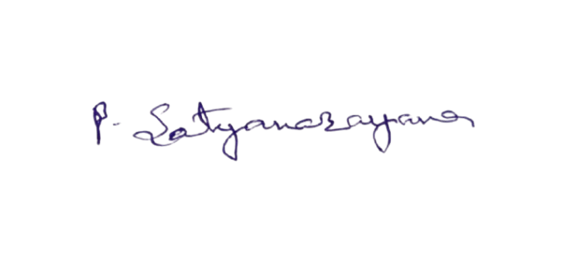 

**SATYANARAYANA PAREPALLY RADHA SRI YERRAMALLA**

**(DIN: 10953714) (DIN: 10953715)**

**Date: 25.03.2025**

**Place: Hyderabad**